Name _____________________________________
Ms. Pekatos
Period ____________
Date _____________
Sonnet 18 | Similarities | Sonnet 130
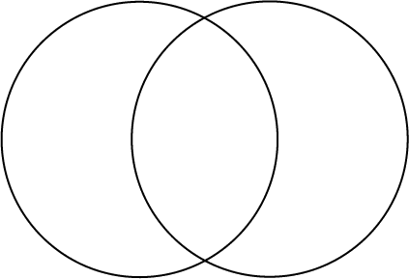

Name _____________________________________
Ms. Pekatos
Period ____________
Date _____________
Sonnet 18 | Similarities | Sonnet 130

